**Diffusion in Living Things**

1. Match the common adaptation for efficient diffusion to the corresponding reason on the diagram below:

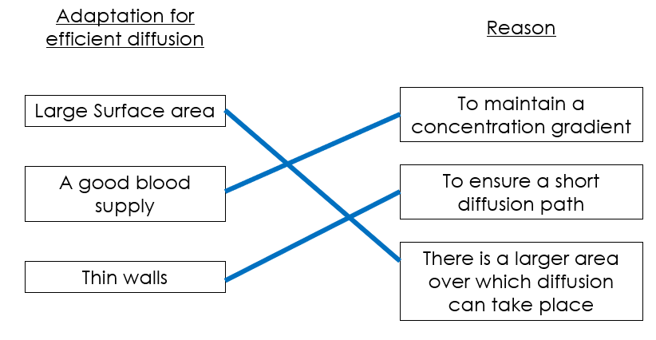

1. The image shows a close up of an alveolus with its blood supply.
   1. A picture containing shape

      Description automatically generated Identify the gas that will diffuse from the alveolus into the blood.

**Oxygen**

* 1. Identify the gas that will diffuse from the blood into the alveolus.

**Carbon Dioxide**

1. Describe how this alveolus is adapted to allow efficient diffusion.

* **Only one cell thick – short path for diffusion.**
* **Good blood supply – maintains concentration gradient**
* **Large surface area**
* **(Moist – allows substances to dissolve before they diffuse)**

1. Explain why efficient diffusion is important to the function of the alveolus.

**Needed to get oxygen into the body for cellular respiration and remove carbon dioxide as it is toxic to cells.**

1. Diagram

   Description automatically generatedThe image shows a close up of villi in the small intestine.
   1. Identify a substance that will diffuse from the small intestine into the blood.

**Glucose/sugar (or amino acids or fatty acids and glycerol)**

* 1. Describe how these villi are adapted to allow efficient diffusion.
* **Large surface area due to shape.**
* **Efficient blood supply to maintain concentration gradient.**
* **Epithelial layer is only one cell thick – short path for diffusion**
  1. Explain why efficient diffusion is important to the function of the villi.

**To get glucose into bloodstream and into cells to allow aerobic respiration to take place to produce energy for the body**

1. The image shows a close up of a synapse.
   1. Describe how this synapse is adapted to allow efficient diffusion.

* **Small gap between neurons – short path for diffusion.**
* **Large surface area.**
* **Vesicles ensure chemicals are released to maintain concentration gradient.**



* 1. Explain why efficient diffusion is important to the function of the synapse.

**Needed to convey messages and signals throughout the body for movement and response.**



1. The image below shows a placenta. Describe how it is adapted to allow efficient diffusion.



* **Massive efficient blood supply to deliver oxygen and remove waste – foetus cannot remove waste on its own so it needs placenta to do this**
* **Large surface area**

Stretch activity: Diffusion of glucose from the small intestine into the bloodstream is not always possible. Discuss when and would this not be possible.

* **Diffusion needs a concentration gradient**
* **Cannot happen when there is no concentration gradient – i.e. concentration of glucose is the same in the bloodstream as it is in the small intestine**
* **Happens after diffusion has been happening for some time, e.g. hours after a meal.**